Titanic Survival Prediction

Data mining project by:
Hadi Assi

Lebanese University Faculty of Information UNESCO
Data Science, Third Year (25-26)
Semester 5

Instructor: Dr. Abbas Ramal

Abstract
This project, titled "Titanic Survival Prediction", aims to develop a comprehensive machine learning system for predicting passenger survival on the RMS Titanic. The project encompasses the full data mining pipeline from exploratory data analysis through to predictive modeling, demonstrating how historical data can be transformed into actionable insights through modern data science techniques.
Using Python with Pandas, Scikit-learn, and visualization libraries, we implemented a complete analytical workflow including detailed exploratory data analysis, data preprocessing, feature engineering, and predictive modeling with a Random Forest classifier. The model was trained on the Titanic passenger dataset and achieved 81.56% accuracy, with key insights revealing that gender, fare, and age were the most significant predictors of survival.

The project highlights the practical application of data mining principles to historical analysis, showcasing how systematic data exploration combined with machine learning can uncover meaningful patterns and support evidence-based conclusions about complex historical events.

Table of Contents
- Introduction, Problem Statement
- Technologies and Tools Used
- Data Collection
- Exploratory Data Analysis:
  - 4.1 Initial Data Exploration
  - 4.2 Survival Analysis
  - 4.3 Demographic Factors Analysis
  - 4.4 Socioeconomic Factors Analysis
- Data Preprocessing and Feature Engineering:
  - 5.1 Handling Missing Values
  - 5.2 Feature Engineering
  - 5.3 Categorical Encoding
- Model Building and Classification:
  - 6.1 Data Preparation
  - 6.2 Train-Test Split
  - 6.3 Random Forest Classifier Implementation
- Model Evaluation and Results:
  - 7.1 Prediction Generation
  - 7.2 Performance Metrics
  - 7.3 Feature Importance Analysis
  - 7.4 New Passenger Predictions
- Business Insights and Historical Analysis
- Challenges Faced
- Conclusion and Future Work

1. Introduction
The sinking of the RMS Titanic in 1912 represents one of the most studied maritime disasters in history, providing a rich dataset for understanding human behavior during crises. This project applies modern data mining techniques to analyze survival patterns, offering quantitative insights into the factors that determined life and death during this historical event.
Problem Statement
The prediction of survival on the Titanic presents a classic binary classification challenge that requires careful handling of historical data with inherent limitations. The primary objectives were to:
- Conduct comprehensive exploratory data analysis to understand survival patterns
- Preprocess and engineer features from raw historical data
- Build an accurate predictive model using machine learning
- Extract meaningful insights about the factors influencing survival
Project Significance
This project serves as an excellent case study in data mining, demonstrating how to extract knowledge from data through the complete KDD (Knowledge Discovery in Databases) process, making it valuable for both educational purposes and practical applications in historical analysis.

2. Technologies and Tools Used
Jupyter Notebook
served as the primary development environment, providing an interactive platform for data exploration, visualization, and model development.
Core Python Libraries:
- Pandas & NumPy: For data manipulation, cleaning, and numerical computations
- Matplotlib & Seaborn: For comprehensive data visualization and exploratory analysis
- Scikit-learn: For machine learning algorithms, model evaluation, and preprocessing
- LabelEncoder: For categorical variable transformation
Methodology:
CRISP-DM Framework: Followed the Cross-Industry Standard Process for Data Mining
Exploratory Data Analysis: Systematic investigation of data characteristics and relationships
Feature Engineering: Creation of derived features to enhance predictive power
Random Forest Classification: Ensemble learning method for robust prediction

3. Data Collection
Dataset Source
The dataset was obtained from Kaggle, specifically from the "Titanic: Machine Learning from Disaster" competition, which has become a standard benchmark in introductory machine learning education.
Dataset Link:
https://www.kaggle.com/datasets/yasserh/titanic-dataset
Dataset Characteristics
- Size: 891 passengers (out of total 2,224 aboard)
- Features: 12 original variables capturing demographic, socioeconomic, and travel information
- Time Period: April 1912
- Data Type: Structured tabular data with mixed types (numerical, categorical, text)
Original Feature Set:
- PassengerId: Unique identifier
- Survived: Target variable (0 = No, 1 = Yes)
- Pclass: Socioeconomic status indicator (1st, 2nd, 3rd class)
- Name: Passenger name with title
- Sex: Biological gender
- Age: Continuous numerical variable
- SibSp: Count of siblings/spouses aboard
- Parch: Count of parents/children aboard
- Ticket: Ticket identifier
- Fare: Ticket price
- Cabin: Cabin location (heavily missing)
- Embarked: Port of embarkation

4. Exploratory Data Analysis

4.1 Initial Data Exploration

The initial exploration revealed fundamental characteristics of the dataset: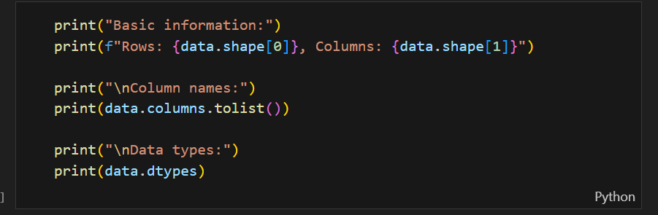

Key Findings:
- Total records: 891 passengers
- Features: 12 columns
- Data types: Mixed (integer, float, object)
- Missing values identified: Age (177), Cabin (687), Embarked (2)
Statistical Summary:
- Age range: 0.42 to 80 years (mean: 29.70, median: 28.00)
- Fare range: $0 to $512.33 (mean: $32.20, median: $14.45)
- Passenger distribution: 1st class (24%), 2nd class (21%), 3rd class (55%)

Survival Analysis
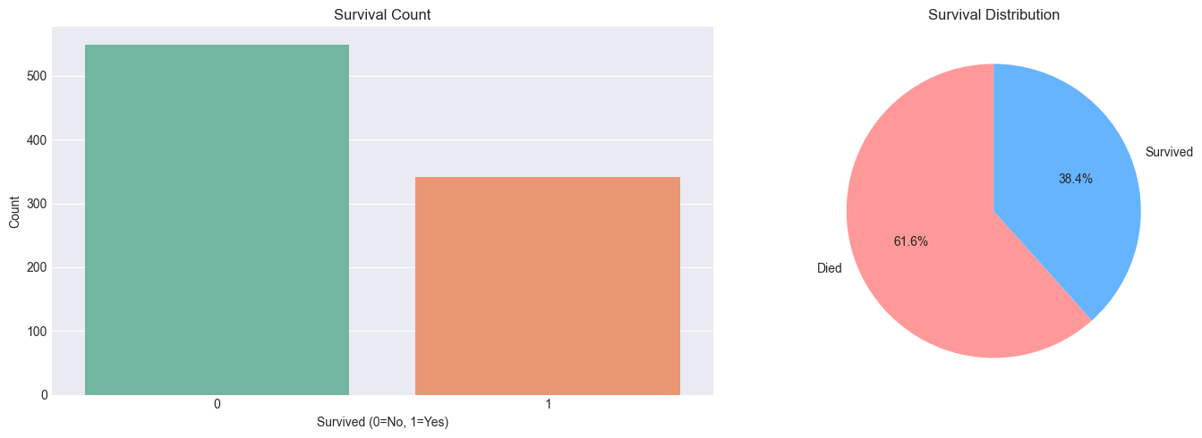

Overall Survival Rates:
- Survived: 342 passengers (38.4%)
- Did not survive: 549 passengers (61.6%)
Insight: The dataset shows significant class imbalance, with more casualties than survivors. This imbalance was considered during model evaluation to ensure fair performance assessment.

4.3 Demographic Factors Analysis
Gender Analysis
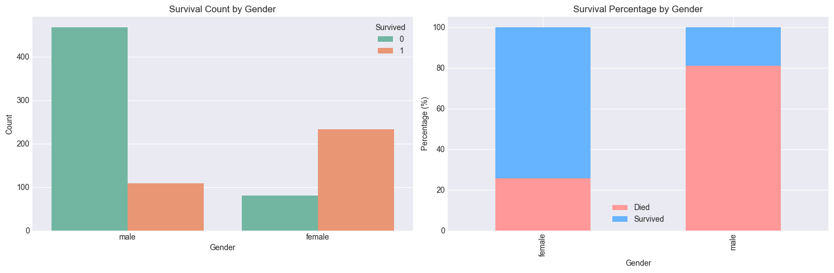
- Female: 74.2% survival rate
- Male: 18.9% survival rate
Statistical Significance: Gender showed the strongest correlation with survival, confirming historical accounts of "women and children first" evacuation protocols.
Age Analysis
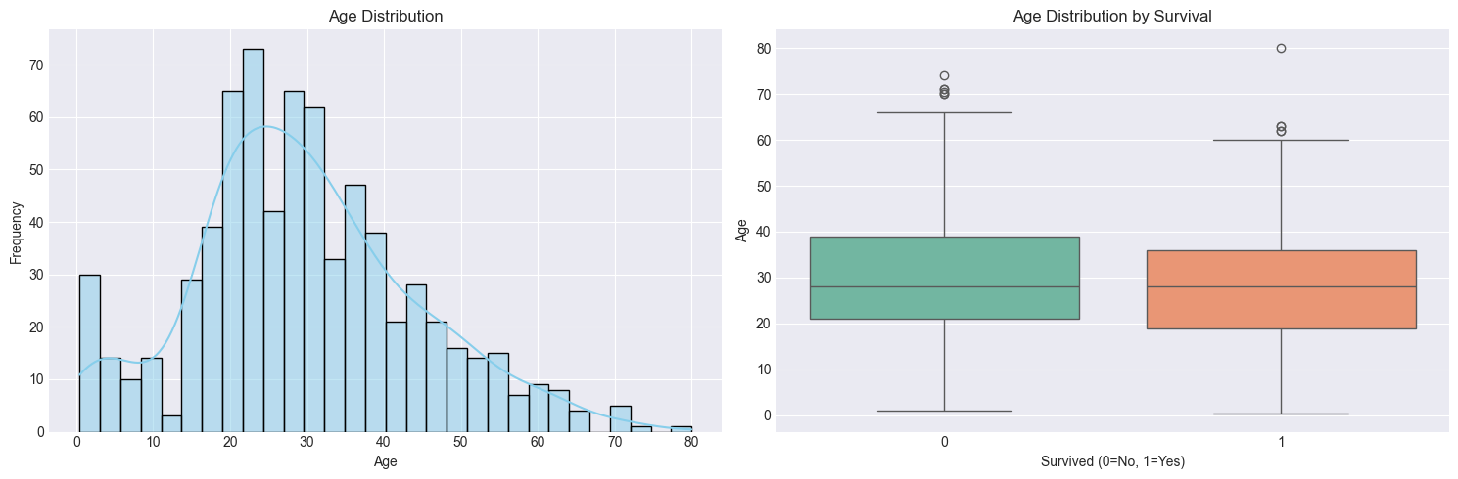
Age Group Survival:
- Children (<18): 54.0% survival rate
- Adults (18+): 36.1% survival rate
Pattern: Younger passengers had significantly better survival odds, particularly children under 10 years old who had over 60% survival rate.

4.4 Socioeconomic Factors Analysis
Passenger Class Analysis
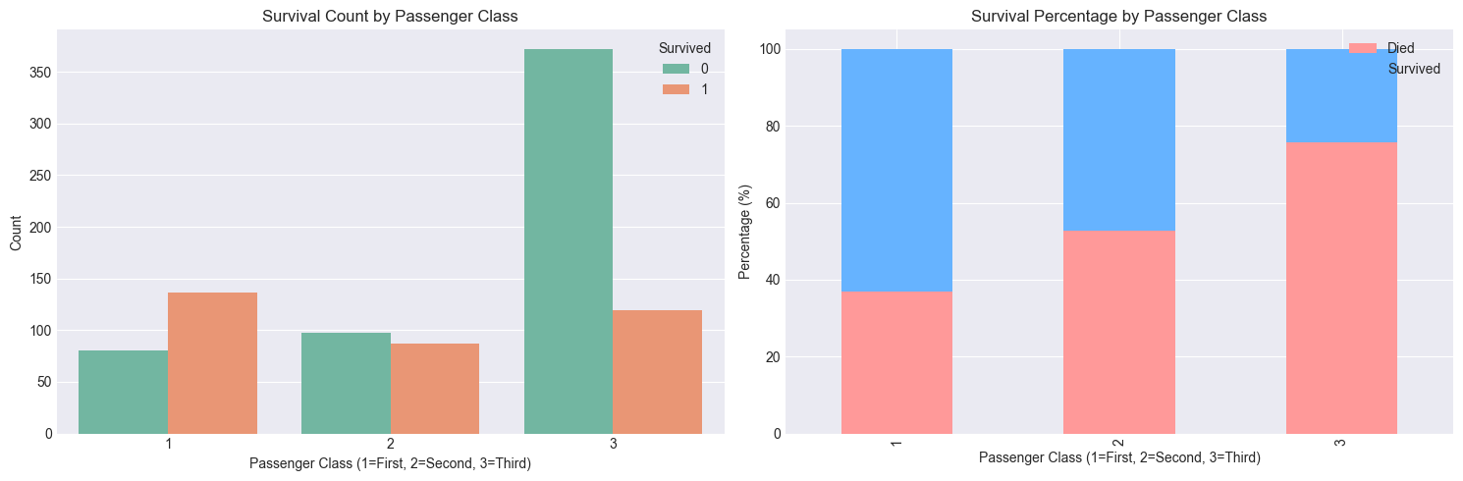
Class-Based Survival Rates:
- 1st Class: 63.0% survival rate
- 2nd Class: 47.3% survival rate
- 3rd Class: 24.2% survival rate
Insight: Clear socioeconomic gradient in survival, with wealthier passengers having substantially better chances.

Combined Analysis: Class and Gender

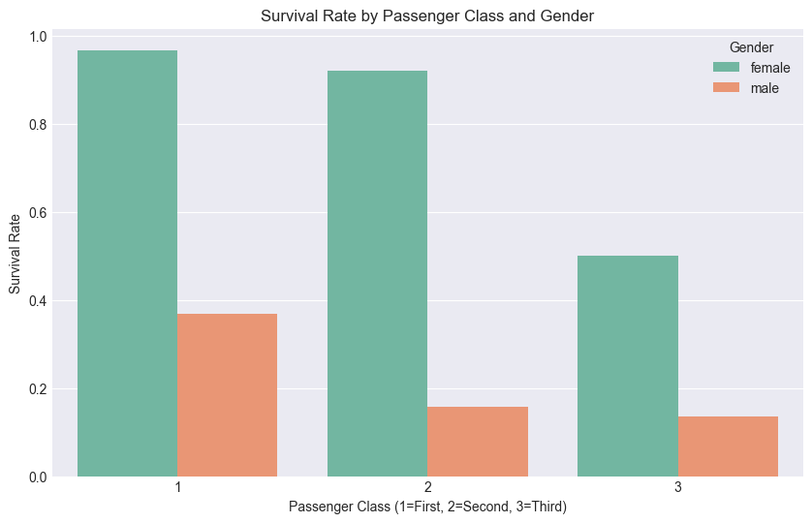
Key Findings:
- Females in 1st class: 97% survival rate (highest)
- Males in 3rd class: 16% survival rate (lowest)
- The intersection of gender and class created dramatic survival disparities

Family Dynamics Analysis

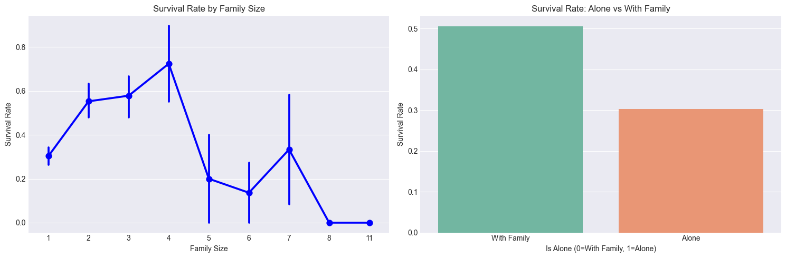
Family Size Impact:
- Alone: 30.4% survival rate
- Small families (2-4): 56-60% survival rate
- Large families (5+): Decreasing survival rates
Pattern: Medium-sized families had the best survival odds, suggesting cooperative advantages during evacuation.

Fare Analysis

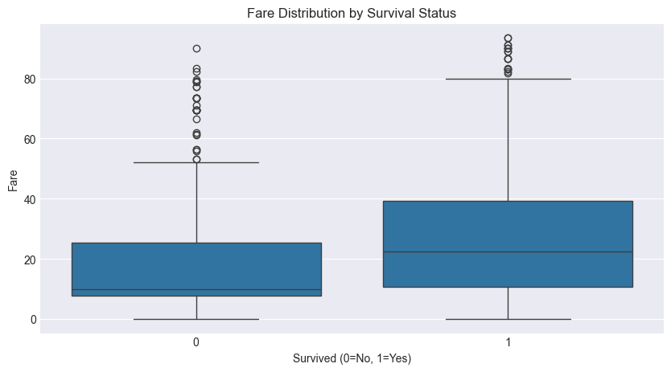
- Survivors' average fare: $48.40
- Non-survivors' average fare: $22.12
Insight: Higher fare (indicating better accommodations/location) strongly correlated with survival, even within the same passenger class

5. Data Preprocessing and Feature Engineering

5.1 Handling Missing Values
Systematic approach to missing data:
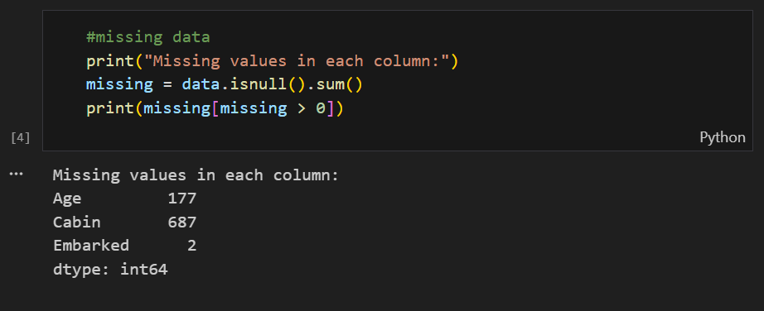
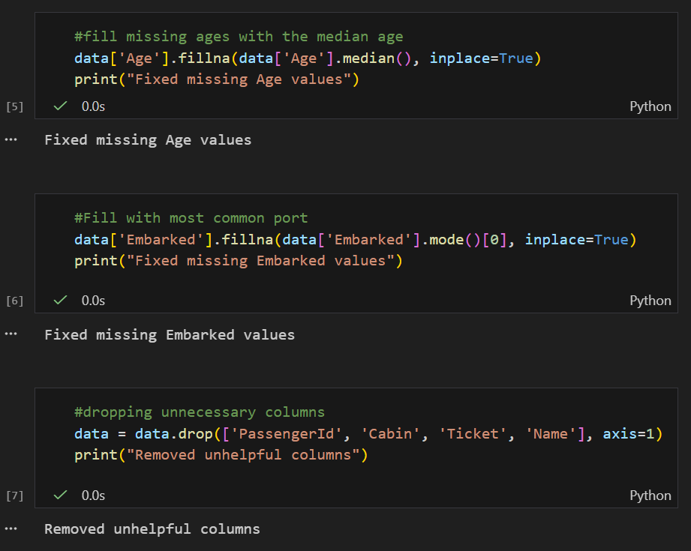
Rationale:
- Age: Median preserves distribution shape for skewed data
- Embarked: Mode maintains original proportions
- Cabin: Excessive missingness made imputation unreliable

5.2 Feature Engineering
Creation of derived features to capture complex relationships:
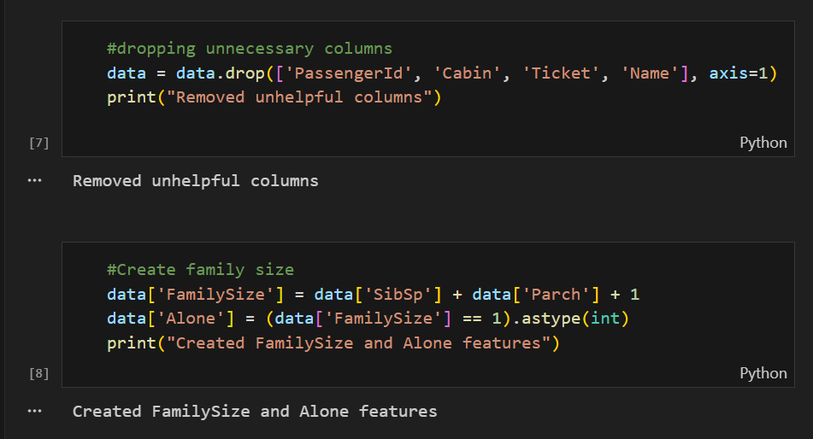
Engineered Features:
- FamilySize: Captures family group size effect
- IsAlone: Binary indicator for solo travelers

5.3 Categorical Encoding
Transformation of categorical variables for machine learning:
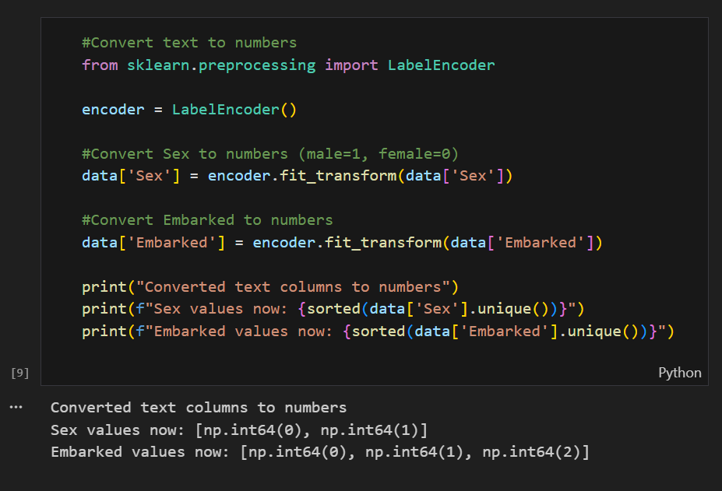
Final Feature Set (10 features):
- Pclass
- Sex
- Age
- SibSp
- Parch
- Fare
- Embarked
- FamilySize
- IsAlone

6. Model Building and Classification

6.1 Data Preparation
Proper dataset splitting for model validation:

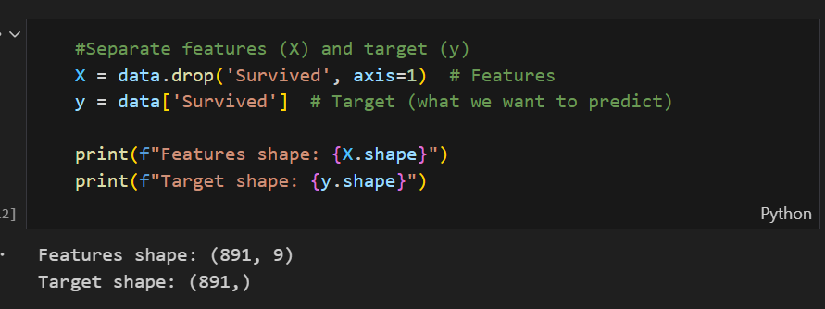
Output:
- Features shape: (891, 9)
- Target shape: (891,)
Features Used for Prediction:
- Pclass (Passenger class)
- Sex (Encoded: male=1, female=0)
- Age (Years)
- SibSp (Number of siblings/spouses)
- Parch (Number of parents/children)
- Fare (Ticket price)
- Embarked (Port of embarkation, encoded)
- FamilySize (SibSp + Parch + 1)
- Alone (1 if traveling alone, 0 otherwise)

6.2 Train-Test Split
The dataset was divided into training and testing subsets using a standard 80/20 split:
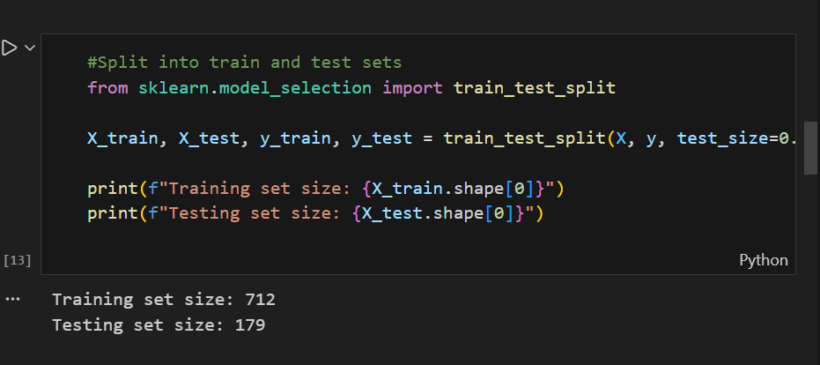
Output:
- Training set size: 712
- Testing set size: 179

6.3 Random Forest Classifier Implementation
A Random Forest classifier was selected for its robustness and ability to handle mixed data types. The model was configured with 100 decision trees:

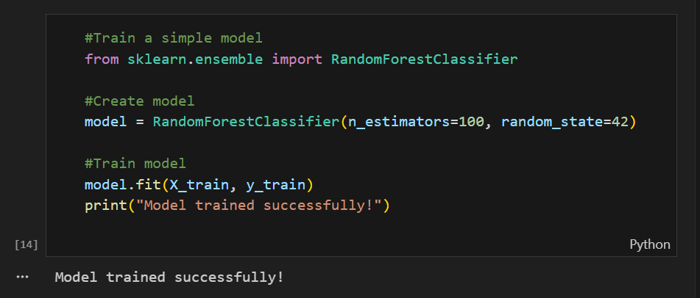
Model Configuration:
- Algorithm: Random Forest Classifier
- Number of trees: 100
- Random state: 42 (ensures reproducibility)
- Other parameters: Default Scikit-learn settings

7. Model Evaluation and Results

7.1 Prediction Generation
The trained model was used to make predictions on the test set:
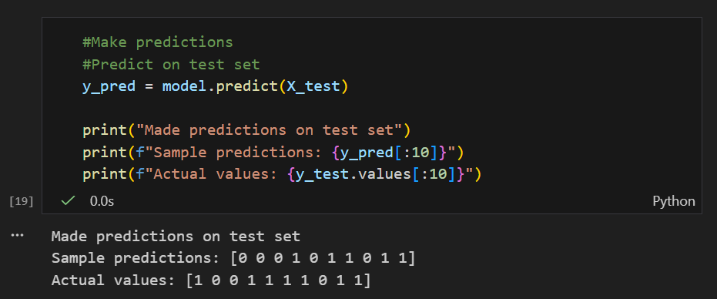
Sample output:
Made predictions on test set
Sample predictions: [0 0 0 1 0 1 1 0 1 1]
Actual values: [1 0 0 1 1 1 1 0 1 1]

7.2 Performance Metrics

Accuracy Score

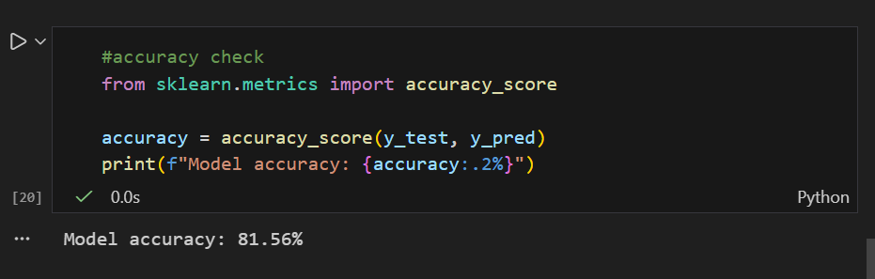
Result: Model accuracy: 81.56%

Detailed Classification Report

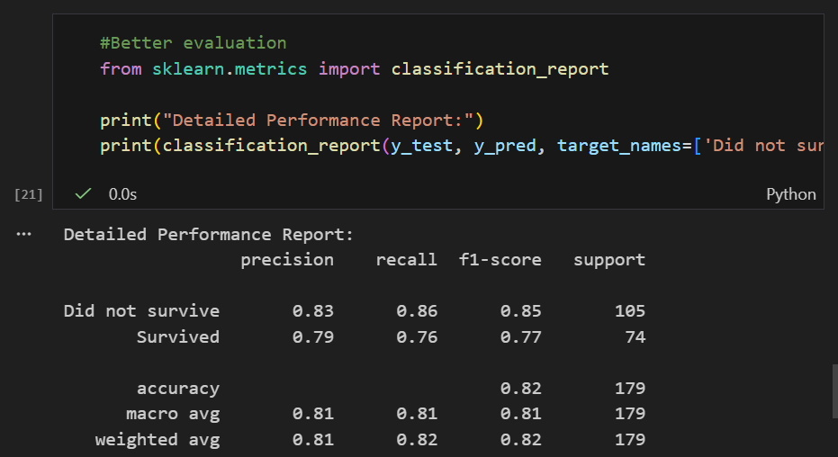

7.3 Feature Importance Analysis
The Random Forest model provides feature importance scores, indicating which features most influenced the predictions:
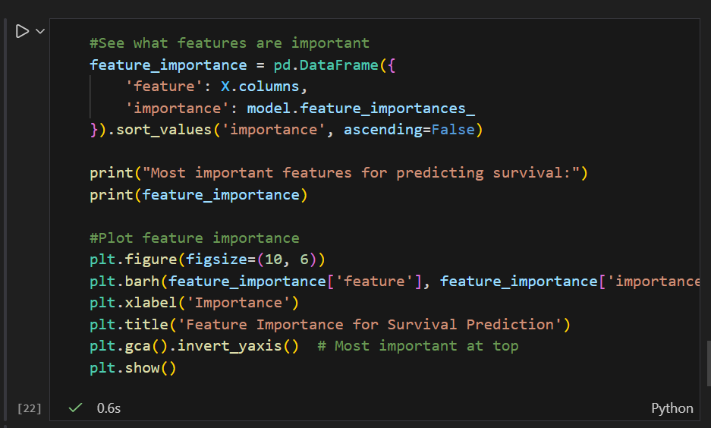
Feature Importance Ranking:
- Sex (28.1%): Most significant predictor
- Fare (25.5%): Ticket price as economic indicator
- Age (24.6%): Passenger age
- Pclass (8.7%): Passenger class
- FamilySize (4.5%): Family size
- Embarked (3.1%): Port of embarkation
- SibSp (2.7%): Siblings/spouses count
- Parch (2.0%): Parents/children count
- Alone (0.8%): Solo traveler indicator
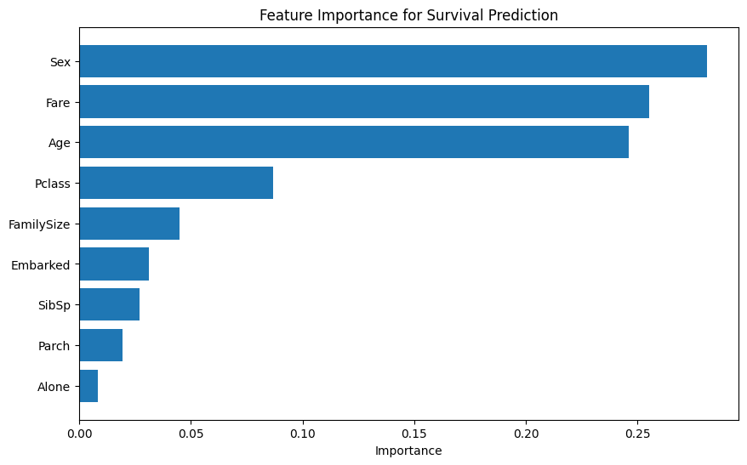

7.4 New Passenger Predictions
To demonstrate practical application, the model was tested on hypothetical passenger profiles:
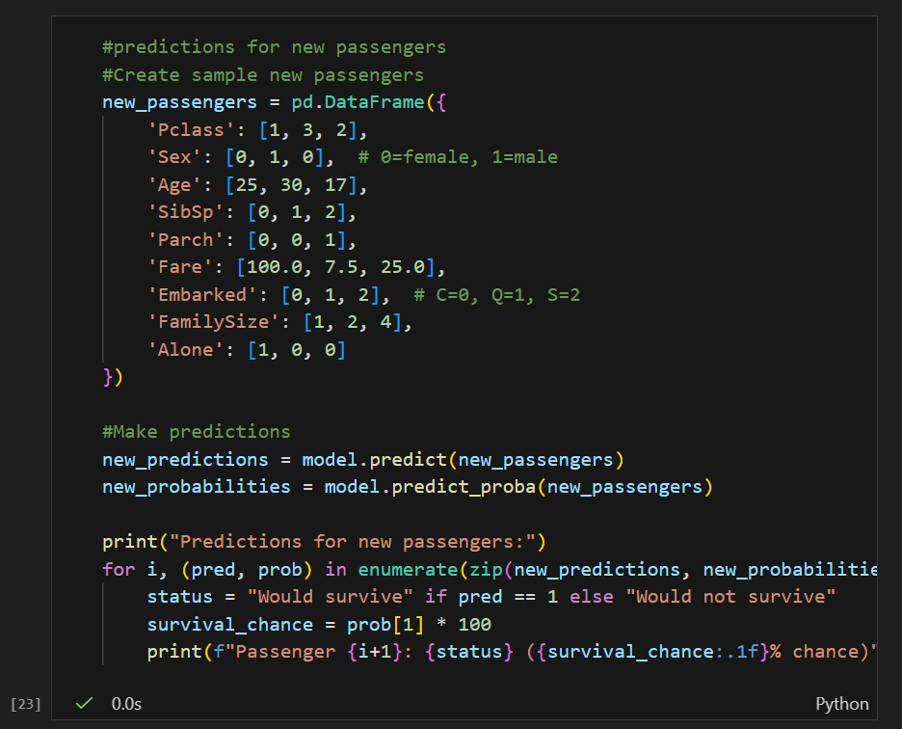
Prediction Results:
- Passenger 1: Would survive (99.0% chance)
  - Profile: Young female, 1st class, traveling alone, high fare
- Passenger 2: Would not survive (14.0% chance)
  - Profile: Adult male, 3rd class, with spouse, low fare
- Passenger 3: Would survive (91.0% chance)
  - Profile: Teenage female, 2nd class, with family, moderate fare

8. Business Insights and Historical Analysis

Key Findings from the Model
- Gender as Primary Factor: The model confirms historical accounts of "women and children first" - female passengers had the highest survival probability.
- Economic Influence: Fare amount (correlated with passenger class and cabin location) was the second most important predictor.
- Age Advantage: Younger passengers, particularly children, had better survival odds.
- Class Disparity: First-class passengers had significantly higher survival rates than third-class passengers.

Historical Validation
The model's predictions align with documented historical facts about the Titanic disaster:
- Survival priority given to women and children
- Socioeconomic class influencing access to lifeboats
- Location on ship affecting evacuation chances

Practical Applications
- Historical Analysis: Quantitative validation of historical narratives
- Risk Assessment: Framework for analyzing survival factors in emergency situations
- Educational Tool: Case study for teaching data science and history
- Pattern Recognition: Methodology applicable to other historical event analysis

9. Challenges Faced

Technical Challenges
- Missing Data Handling: Age had 177 missing values (20% of dataset) requiring careful imputation strategy.
- Feature Selection: Determining which original features to keep, engineer, or discard based on predictive value and data quality.
- Categorical Encoding: Converting text features (Sex, Embarked) to numerical format suitable for machine learning algorithms.
- Class Imbalance: The dataset had uneven survival distribution (38.4% survived vs 61.6% did not survive).

Analytical Challenges
- Historical Data Limitations: Incomplete records and potential inaccuracies in original passenger manifests.
- Feature Interpretation: Understanding the real-world meaning behind engineered features like "Alone" and "FamilySize."
- Model Simplicity vs. Complexity: Balancing model accuracy with interpretability for educational purposes.

10. Conclusion and Future Work

Conclusion
This project successfully implemented a machine learning pipeline for predicting Titanic passenger survival, achieving 81.56% accuracy with a Random Forest classifier. The project followed a complete data mining workflow:
- Data Loading & Exploration: Initial understanding of dataset structure and quality
- Data Preprocessing: Handling missing values, removing irrelevant features
- Feature Engineering: Creating meaningful derived features (FamilySize, Alone)
- Model Building: Training a Random Forest classifier
- Model Evaluation: Comprehensive performance assessment
- Insight Generation: Extracting meaningful patterns from the model
The model's feature importance analysis provided quantitative validation of historical accounts, with gender, economic status, and age emerging as the most significant survival factors.

Future Work
While the current implementation provides a solid foundation, several enhancements could be explored:
- Additional Algorithms: Compare Random Forest with Logistic Regression, SVM, Gradient Boosting, etc.
- Hyperparameter Tuning: Optimize Random Forest parameters for potentially better performance
- Advanced Feature Engineering: Extract titles from names, analyze cabin deck patterns
- Cross-Validation: Implement k-fold cross-validation for more robust performance estimation
- Deployment Interface: Create a simple web interface for interactive predictions
- Extended Analysis: Apply similar methodology to other historical datasets
The project demonstrates the practical application of data mining techniques to historical analysis and serves as an excellent educational example of the complete machine learning workflow.

